

Configuring a Small Office/Home Office Environment for Fortinet Firewall

Rui Zhao, CCNA
Purpose:

The purpose of this lab is to set up and configure the Fortinet Firewall into a Small Office/Home Office configuration and set up basic firewall policies.

Background Information:

Fortinet is a cybersecurity company that was first founded by Ken Xie and Michael Xie in San Francisco Bay Area in 2000, initially selling their first product FortiGate. This product was a physical firewall, used to address performance gaps in network security. Following its development, along with distributing the product in many Countries – Canada, UK, Asia, Europe, North America – and the company went public into the NASDAQ in November 2009. By 2010, Fortinet has grown into a very prominent company, amounting to $324 million in annual revenues.
To this day, Fortinet has grown to have 900,000+ global customer base and has shipped over 15.9M units of products as of December 31st, 2025. They offer next-generation firewalls that have features such as wireless LAN, FortiGuard AI-powered security services, and SaaS solutions for management.
Fortinet is a security ecosystem and offers many sorts of different products and services. They emphasized in integrating wireless systems into next-generation firewalls, offering different features in order to control the network and cybersecurity. With their integration of the cloud, further expanding their significant role in the ever-growing enterprise IT infrastructure, getting access to cloud providers such as AWS, Microsoft Azure, and Google Cloud Platform. Furthermore, Fortinet has its own cloud-native security tools, called the FortiCNAPP platform, allowing security management with the many different cloud providers.
Comparing Fortinet to other firewall vendors, Fortinet heavily focuses on integrating products together. Furthermore, using multiple Fortinet products will further increase security and threat detection. It isn’t only suitable for SOHO environments, but also enterprise-grade solutions for large organizations.
Fortinet also directly competes with the leading competitors like Cisco, Palo Alto Networks, and Check Point. Combining many different Fortinet systems and ecosystems will grant you access to many different features.
The “Security Fabric” for Fortinet means that every tool plays a role, and they work together. With its tools, it breaks down the threat in real time. First, the suspicious file attempts to enter your network. Then, FortiGate blocks this connection and alerts the FortiAnalyzer, logging the threat into the Fortinet system. After that, the FortiClient would ensure that the threat isn’t opened or executed on any user device. Finally, FortiGuard adds the threat category and instance into their threat database to ensure that other users will also be protected from this threat going forward, making Fortinet a self-evolving firewall capable of scaling with increasing threats and constantly updating its security measures.

Lab Commands:

First, connect your Ethernet Cable into the WAN port on your Fortinet firewall and connect the other end to an ethernet switch of any port. Then, connect your other Ethernet Cable to E0/1 and your other end to your PC.
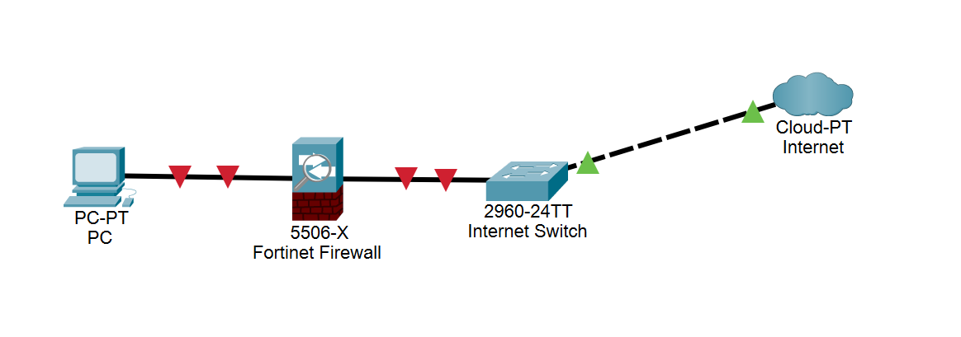
Then, head over to 192.168.1.99. This is Fortinet firewall’s default IP address for its web-based interface for the firewall configuration interface. Login with the default login credentials.
Username: admin
Password: (blank)

You should reach this screen when you have successfully logged in.
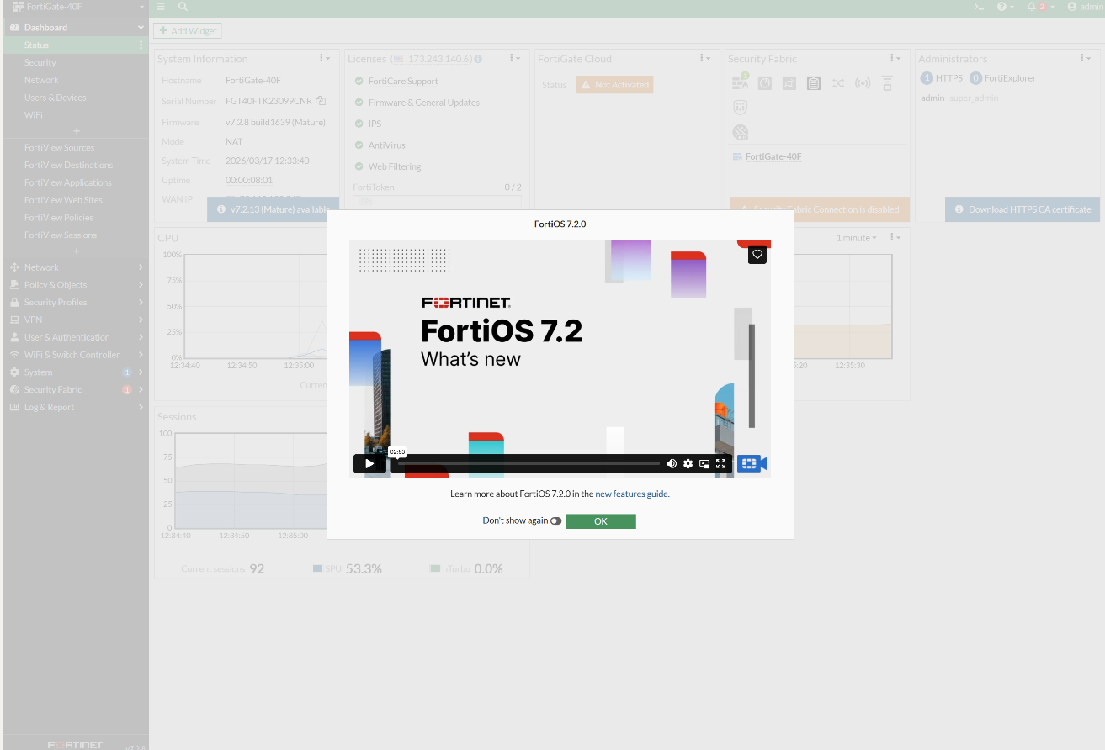
Congratulations, you have entered the Fortinet firewall web interface.

In order to change the hostname and configure the system time of the Fortinet firewall, head over to System Settings and configure the Host Name and the respective time zones.

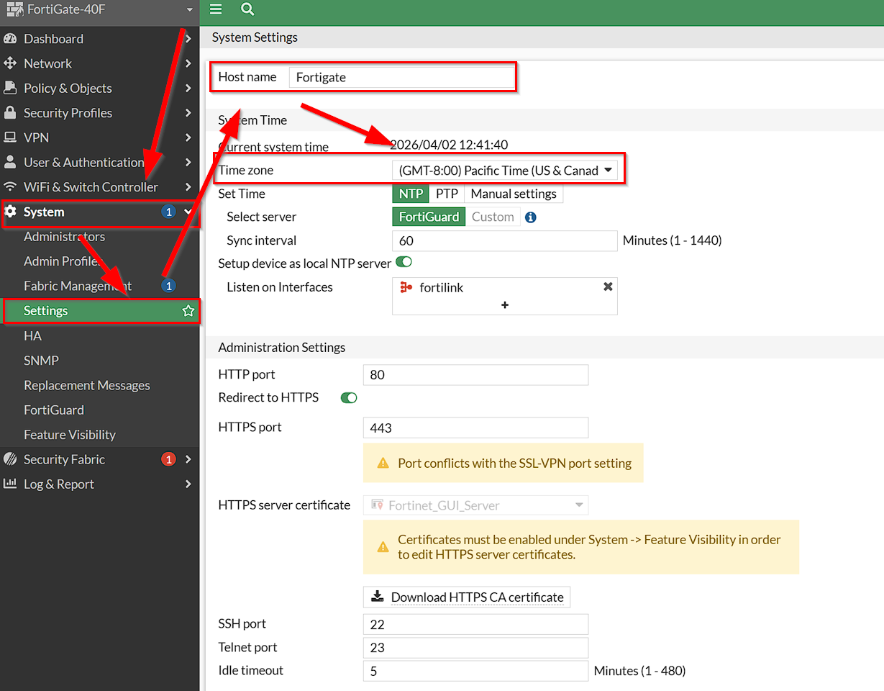

Next, in order to access your interfaces for LAN, WAN, and NAT, head over to Network Interfaces.

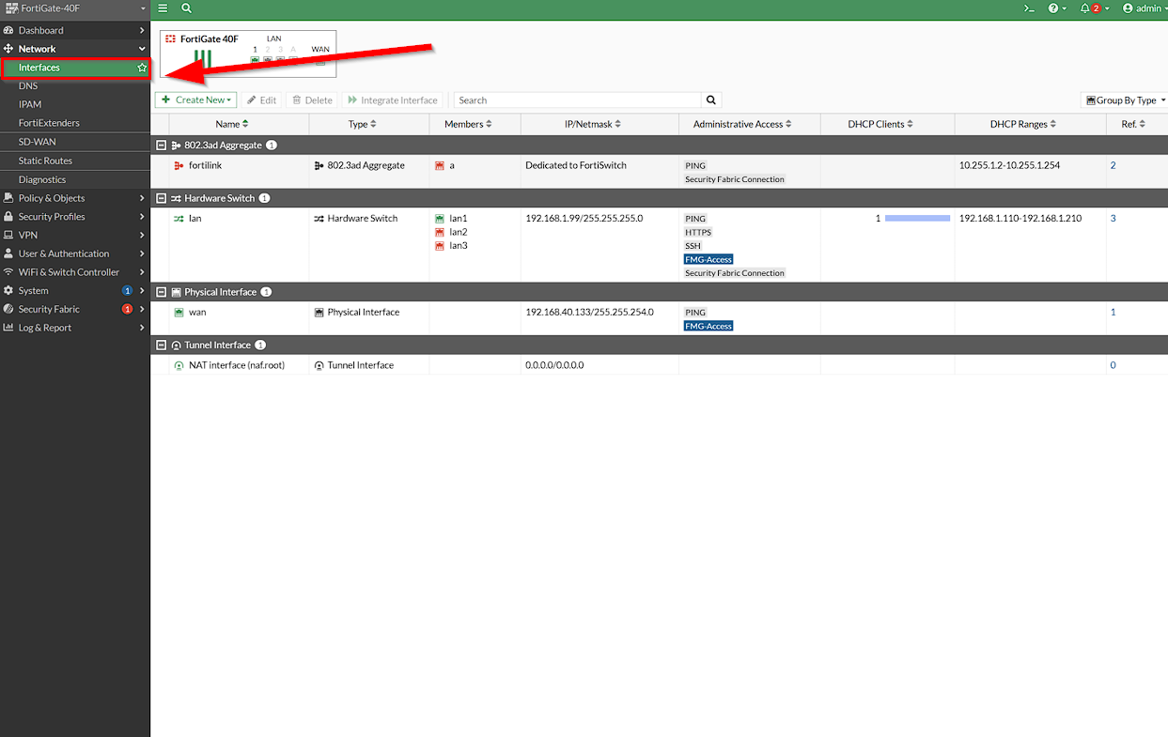

Here you can see your configured interfaces for the different parts of your network. We will first configure the LAN interface.

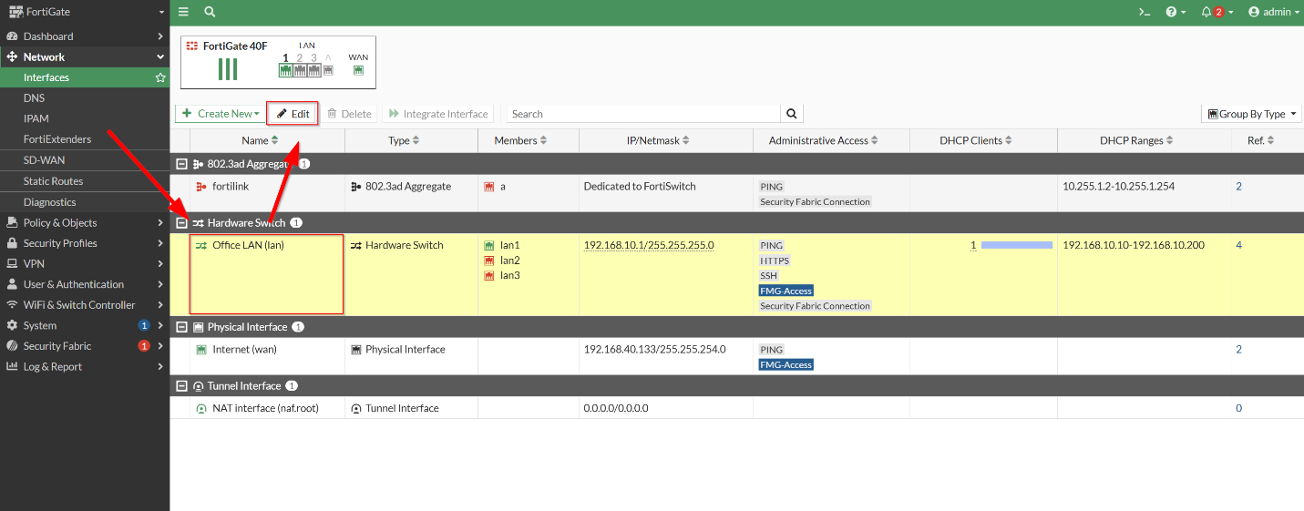

Here you can configure the LAN configuration settings. For this lab, we will be configuring its Alias to Office LAN. You can also optionally change the IP address of the web-based firewall management interface to an IP address of your choice by configuring the IP/Netmask into your desired IP address. For this lab, we changed from the default IP address of 192.168.1.99/24 to 192.168.10.1/24. For DHCP, you can configure the address range for leasing. For demonstration, we have configured the address range of leasing from 192.168.10.10 to 192.168.10.200. Don’t forget to set default gateway to the configured IP/Netmask. When you are finished, press OK to finalize your changes.
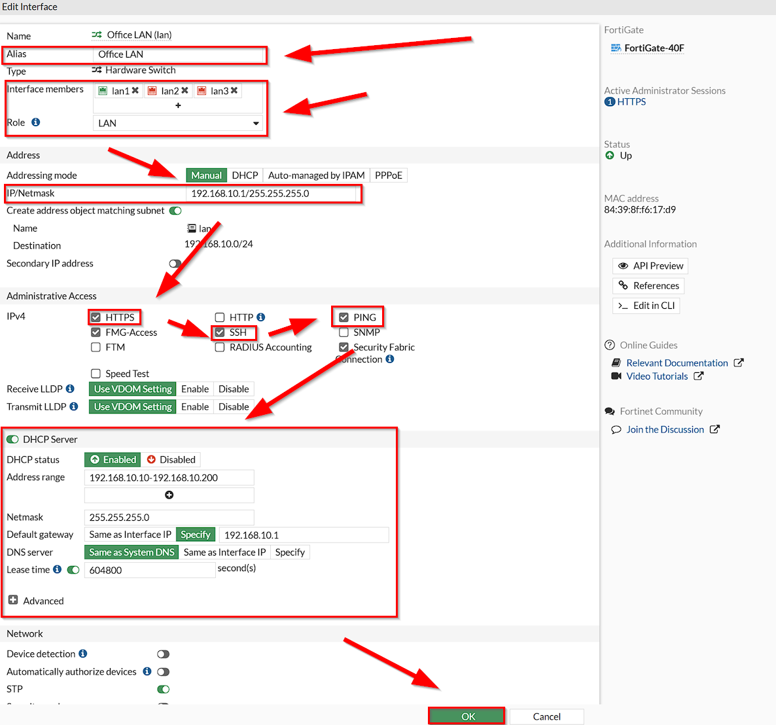

Similarly, by selecting the WAN and clicking on edit, we can also configure its Alias and interface members.

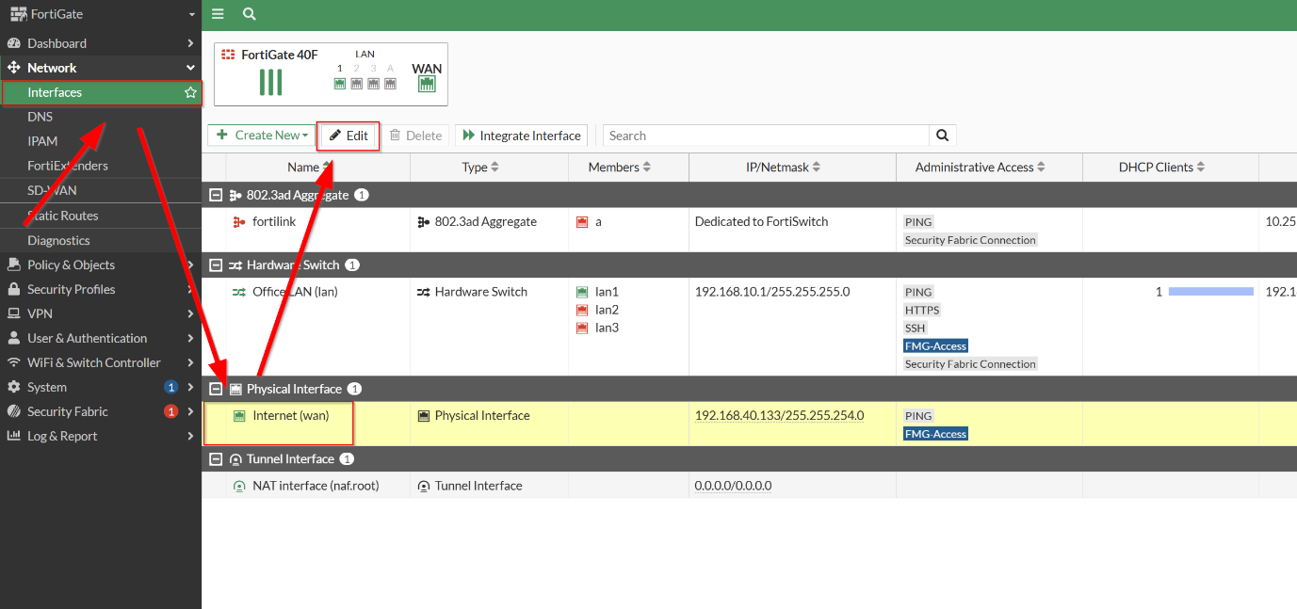

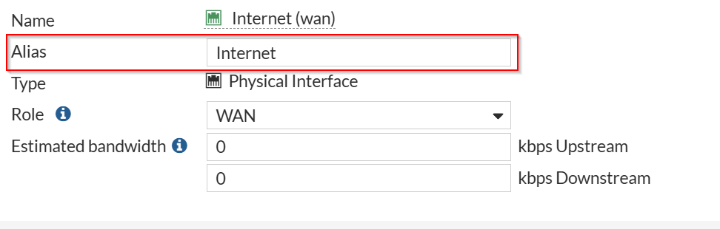

Remember at each configuration, you press OK to save.

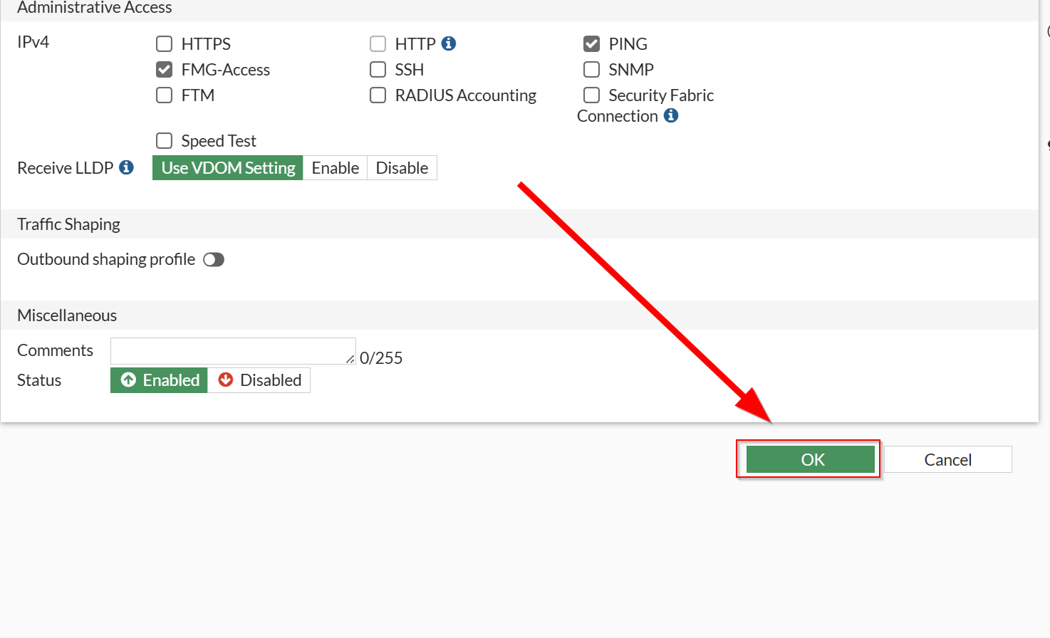
To configure your LAN-to-WAN firewall policy, head over to Policy & Objects Firewall Policy and press Create New.
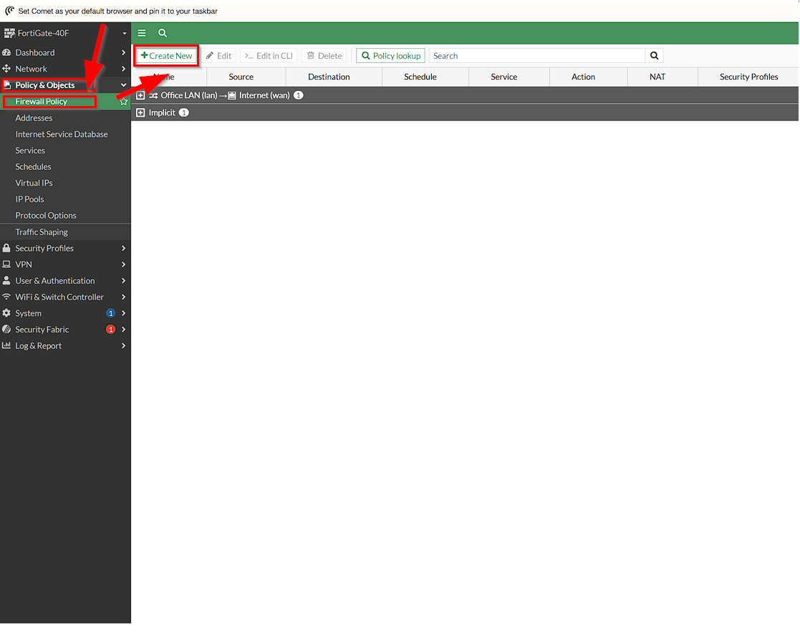
Here, configure these configurations. This will allow LAN to WAN policies that direct traffic from all sources to all destinations, with NAT configurations. When you are done, press OK.

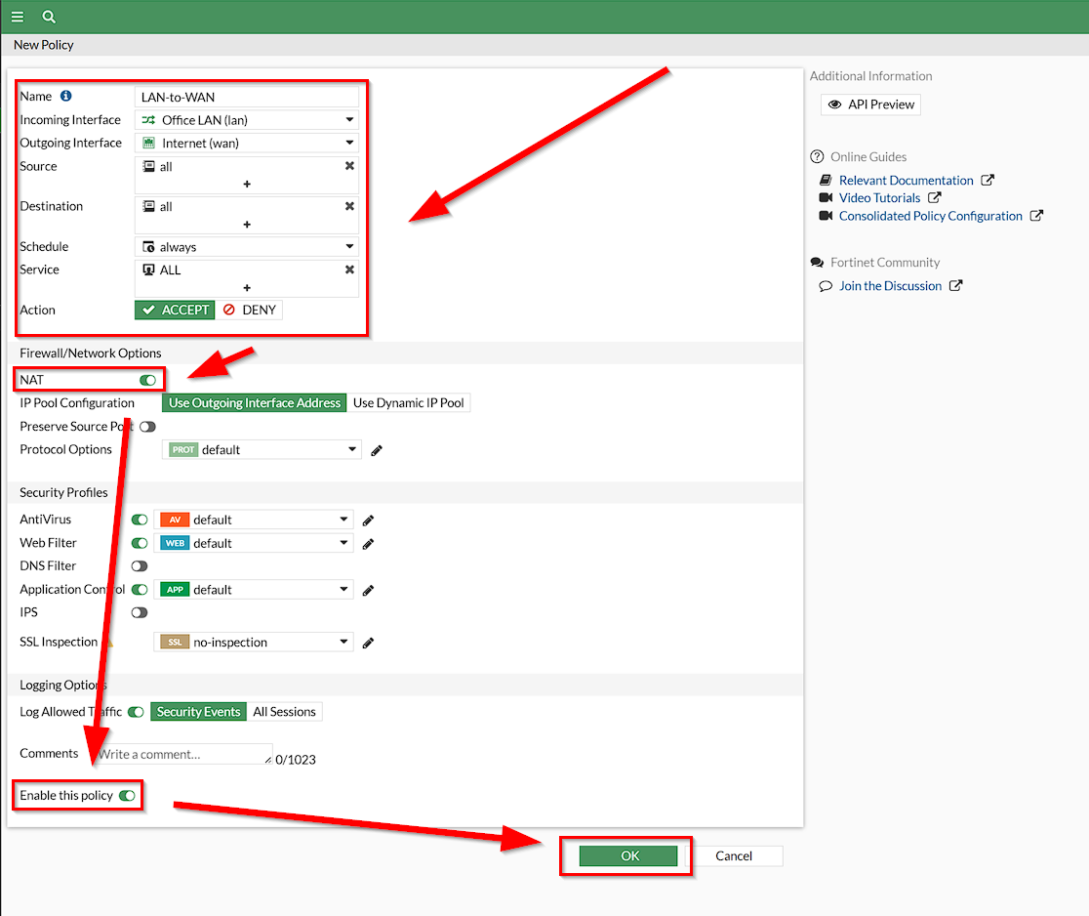

When finished, your screen should look like this.
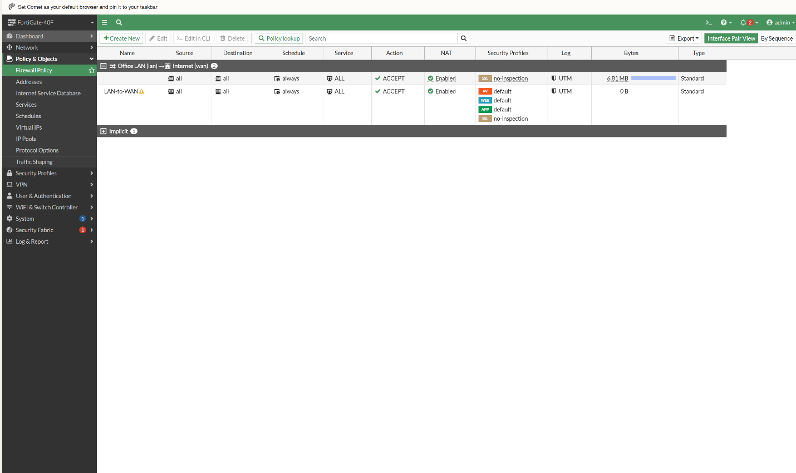

Congratulations, you have made a SOHO configuration for a Fortinet Firewall!

Problems:

One problem that was encountered was finding the right IP address for the firewall. Other firewalls I have worked with in the past all had the default IP address of 192.168.1.1 for its web GUI. However, for Fortinet, the default IP address for its web GUI is 192.168.1.99. This was learned by Fortinet research.

Another problem that was encountered initially was accessing the firewall. The firewall we were given already had existing configuration from other hosts and have changed login credentials. We were fortunate enough to guess the username and password and factory reset the firewall.

Conclusion:

In conclusion, with this lab, I have learned how to configure the basic settings for a SOHO environment. This will grant me the necessary skills to familiarize and configure settings for Fortinet. I’ve also learned through research that Fortinet combines many processes and heavy links to cloud infrastructure for more features. With these areas of improvement and learning, I can definitely apply these concepts into real world cybersecurity.

